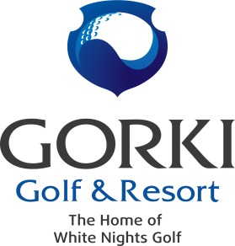

Регламент турнира «Final Swing»
Date | 06.10.2018
 | GORKI Golf & Resort
Registration | по почте: reception@gorkigolf.ru  или по тел.: +7 812 318 09 90
Registration opening | 27.09.2018 в 9:00
Registration closing | 05.10.2018 в 18:00
HCP Groups | HCP Group 1 – Men 0 - 14,0  HCP Group 2 – Men 14,1 - 28,9  HCP Group 3 – Ladies 0 - 30,8  HCP Group 4 – Juniors 0 - 30,8
Price | - 4 000 rubles for members  - 8 000 rubles for gusets  - 2500 rubles for junior members  - 5000 rubles for juniors non-members  - 2000 non-golfers  - PLATINUM members - FREE
Price includes | Breakfast, halfway snacks, dinner, green fee
Dress code | Smart casual
Format | Individual Stableford with HCP
TEE BOX | - MENS - yellow  - LADIES - red
Extra nominations | - Mens Longest Drive – Hole 9;  - Mens Closest to the Pin – Hole 15;  - Ladies Longest Drive – Hole 14;  - Ladies Closest to the Pin – Hole 8;
Определение победителя | The winner is determined by the highest stableford points.  In case of the draw for the 1st place, winner determined by the highest stableford points on the back nine (or 6,3 and last hole)  If several players showed the same results for the 2nd and 3rd places, the highest position will get a player with the lowest hcp.
Start | Shotgun 11:00
Tournament registration | 9:30 – 10:45
Score cards | Clubhouse reception
Price giving | 18:00

